Task 7:

Assign IP address manually on base machine, pc1, pc2, pc3 in the range: 172.20.10.0/24

1.Assign static IP address to pc1, pc2, pc3 as mentioned below.
pc1 -> 172.20.10.11/24
pc2 -> 172.20.10.12/24
pc3 -> 172.20.10.13/24

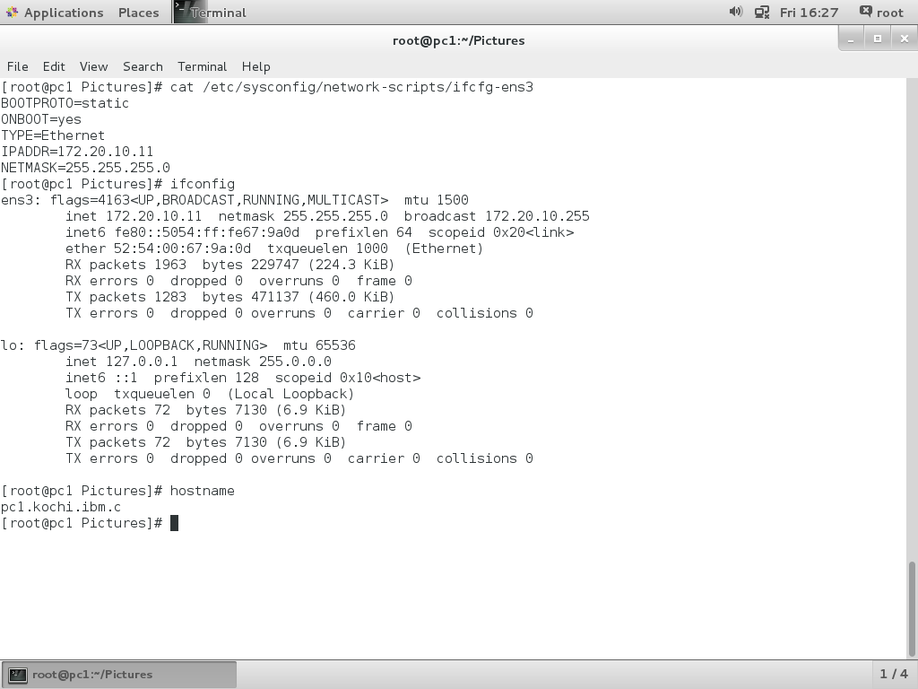

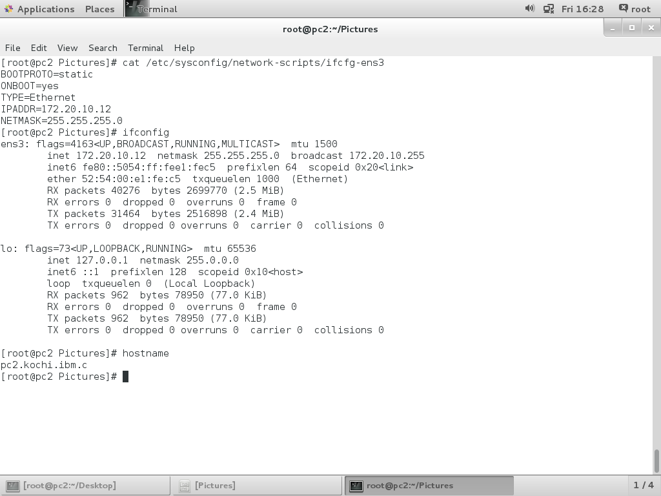
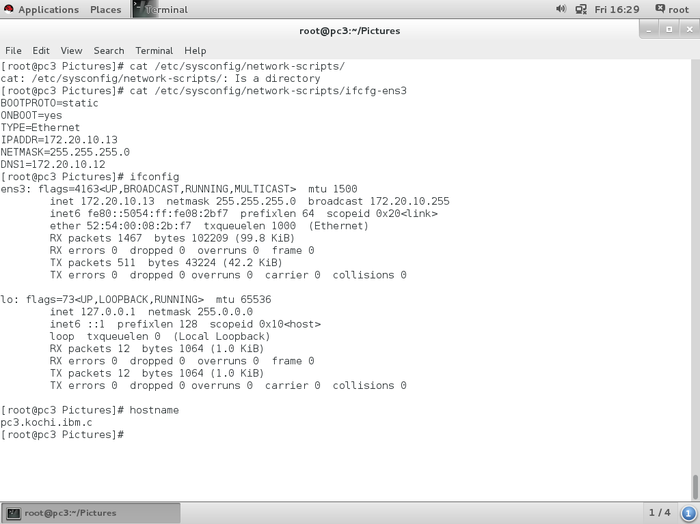
Task 8:

pc4, pc5 should get address from DHCP server

Therefore, Configure PC1 as DHCP Server

1. DHCP server installed in pc1 and bind below mentioned ip address to pc4, pc5.

pc4 -> 172.20.10.14/24
pc5 -> 172.20.10.15/24
2. yum install dhcp
3. vim /etc/sysconfig/dhcpd
DHCPDARGS=ens3 -> interface name
4. mv /etc/dhcp/dhcpd.conf /etc/dhcp/dhcpd.confbak
5. cp /usr/share/doc/dhcp-4.2.5/dhcpd.sample.example /etc/dhcp/dhcpd.conf
6. vim /etc/dhcp/dhcpd.conf

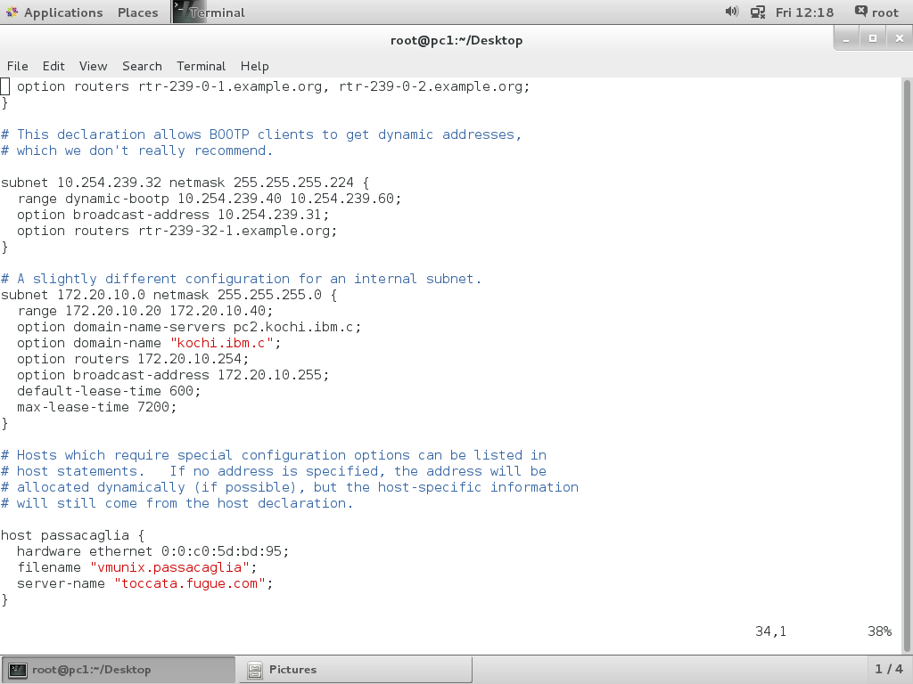

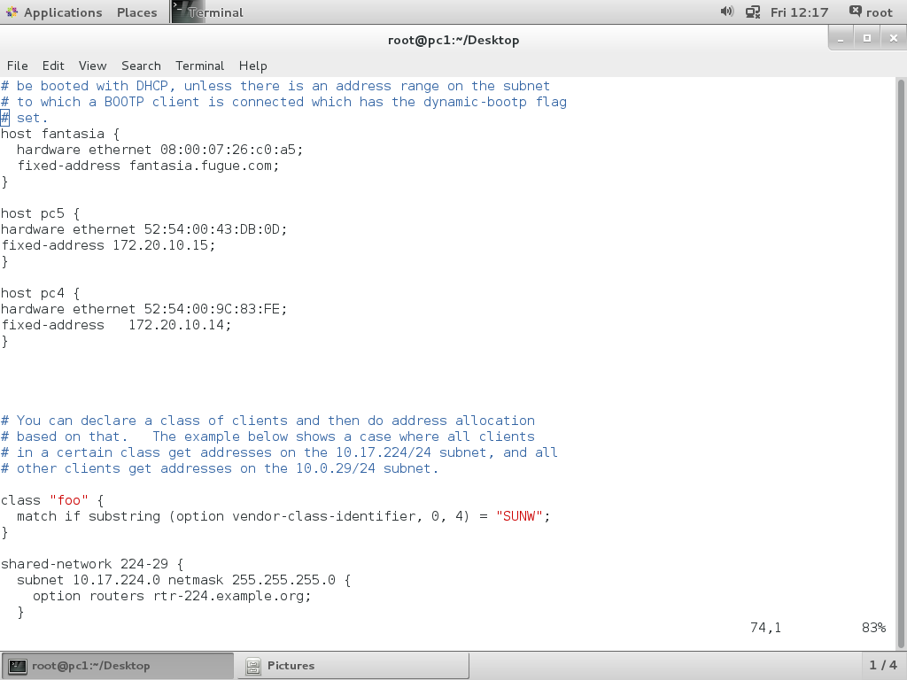
7. systemctl restart dhcp
8. pc4 configured as below.

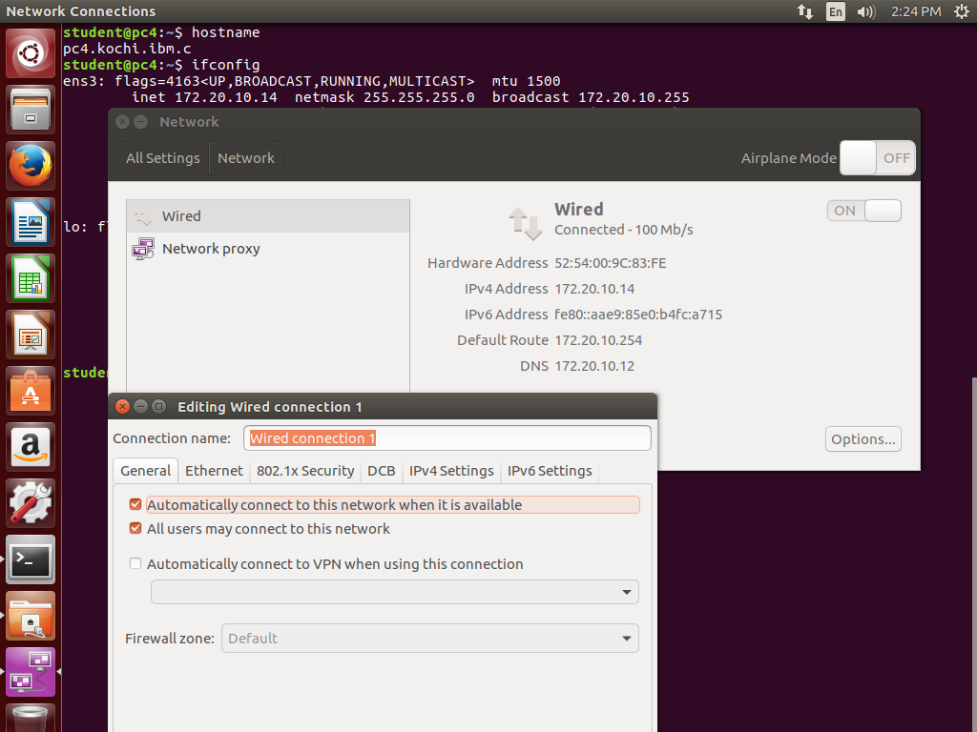
9. pc5 configured as below.

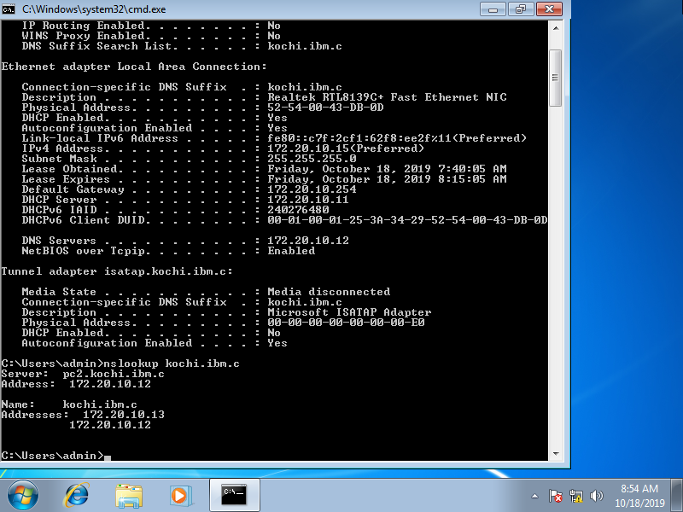
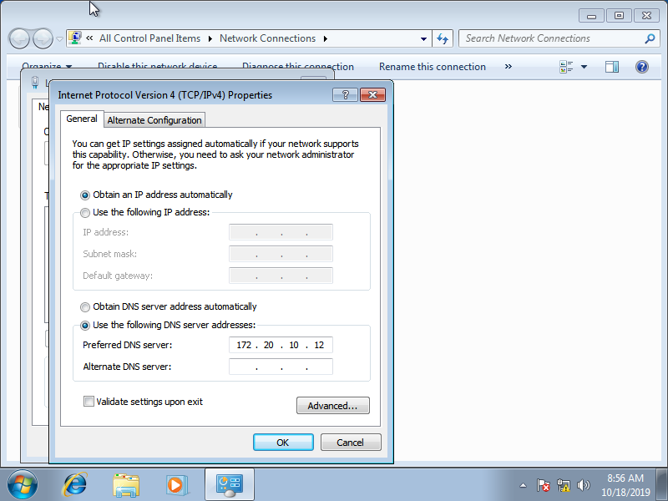

Task 9:
Check whether VM’s / Guest are able to communicate with Host or Base PC

1. Bridge configured in base machine.

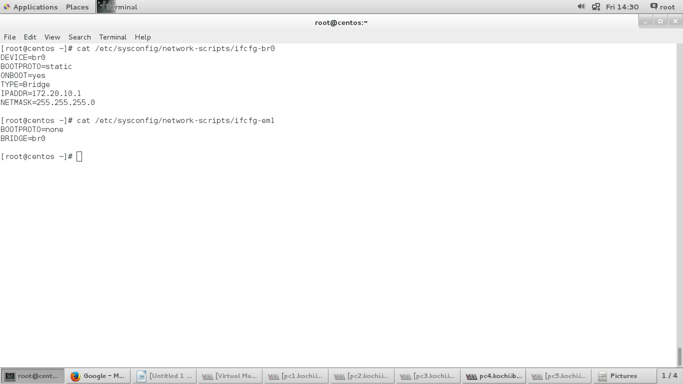
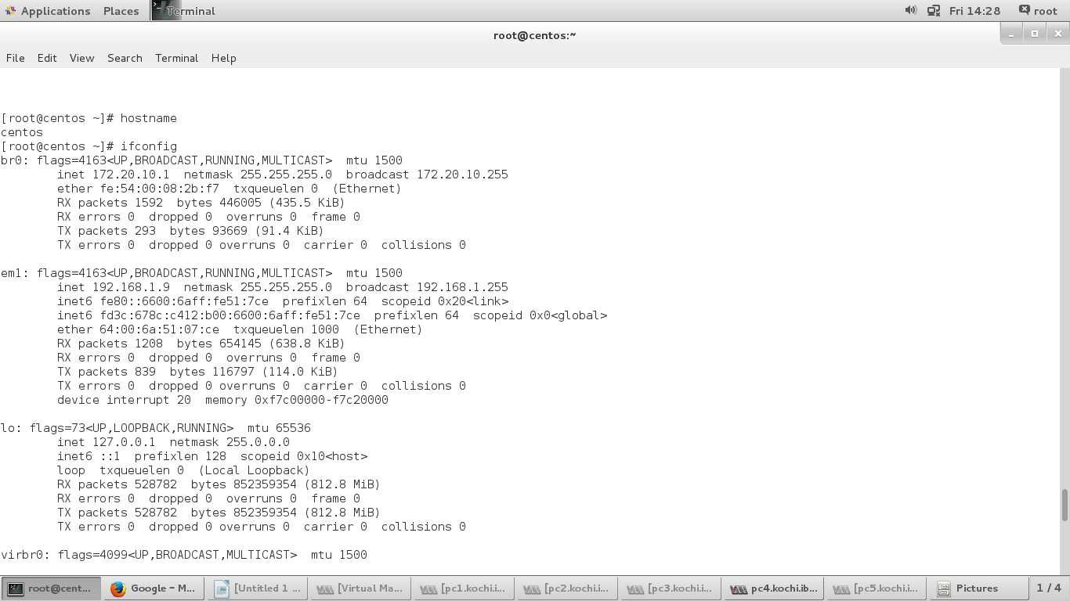

2. pc1 can communicate with base machine, as mentioned below.
